EWMA correlation: EURUSD and USDCHF
Method 06 / daily log returns / lambda = 0.94 / Alpari D1 full available history

Study setup
Logical pair: EURUSD , USDCHF
Broker symbols: EURUSD_i , USDCHF_i
Snapshot: 2026-11-03_majors_alpari_D1
Timeframe: D1
Matched return window: 1999-01-05 to 2026-11-02 (UTC bar dates)
Matched return count n: 7186
Dropped unfinished last bar dated 2026-11-03 UTC after a tick-volume check against the prior complete day.
Lambda: 0.94 (today weight 0.06)
Burn-in ignored in path summaries and chart: first 60 updates
Mean adjustment: each leg demeaned by its mean on the matched rows
Seeds: c_0 = v_x,0 = v_y,0 = 0
Complete matched rows (Excel): EURUSD-USDCHF_EWMA_D1.xlsx
Complete matched rows (HTML table): EURUSD-USDCHF_EWMA_D1_data.html

Method carried forward
EWMA correlation updates covariance and variances of mean-adjusted daily log returns of close, ln(close_t / close_t-1), with lambda = 0.94 (6% weight on today's product or square, 94% on yesterday's EWMA state). Quotes are not inverted. Each leg is demeaned by its mean on the matched rows; that mean uses the full sample, so the rho path is a full-sample description, not a live filter. Seeds start at zero. Path summaries and the chart ignore the first 60 updates so the zero seed has faded. The headline is rho on the last day. rho is symmetric under swap of the two symbols. A high |rho| does not prove cause, lead-lag, or a trading signal. Today's return sits inside today's rho, so the estimate can only inform a later decision. Same-sample Pearson r is a side check only.

Results
Latest EWMA rho: -0.637363
Post-burn-in path (n=7126): mean=-0.829648, median=-0.878878, min=-0.997239, max=0.514828, std=0.165734
Share of post-burn-in days with |rho| >= 0.4: 97.68%; |rho| >= 0.7: 85.22%
Same-sample Pearson r: -0.749204
Latest rho minus r: 0.111840

Conclusion
Over 7186 matched daily log-return rows for EURUSD and USDCHF (broker quote directions unchanged), latest EWMA rho with lambda=0.94 is -0.6374 (negative, moderate recent linear link in this sample). After a 60-day burn-in, path mean is -0.8296, std is 0.1657, and the range is [-0.9972, 0.5148]. Same-sample Pearson r is -0.7492 (latest rho minus r = 0.1118). This does not establish cause, lead-lag, or a lasting trading rule.

Charts
Daily closes

Daily log returns
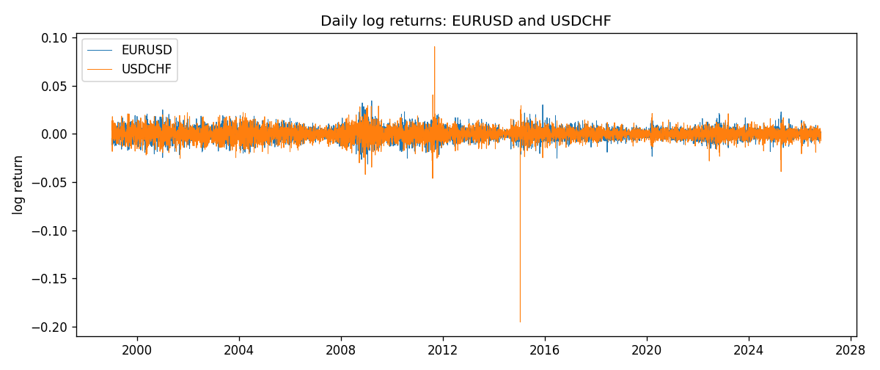
EWMA rho path with Pearson r reference
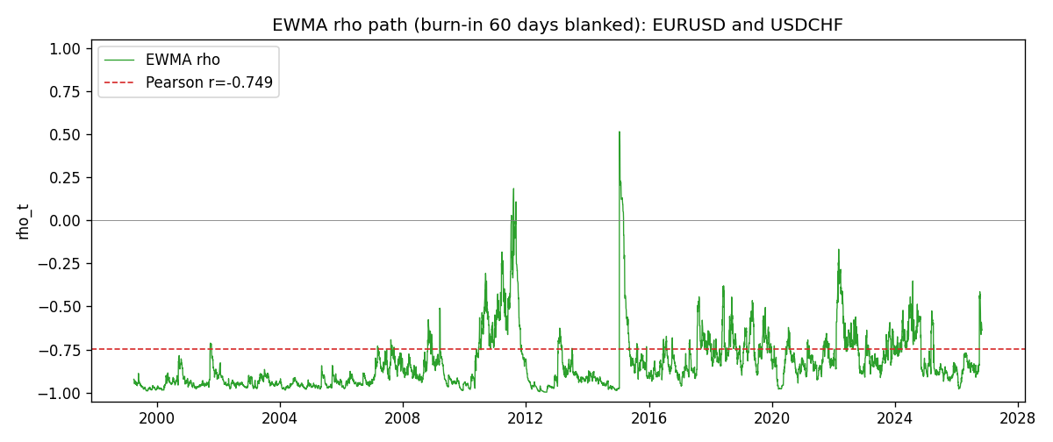

Data report
Every matched row that entered the EWMA recursion is stored in the sibling Excel workbook named EURUSD-USDCHF_EWMA_D1.xlsx. That file is the complete data archive for redrawing charts. Embedding all rows as a Word table is impractical at this length; the Word file holds the column list, column summaries, and the first and last 15 matched rows.
Columns: time, EURUSD_open, USDCHF_open, EURUSD_high, USDCHF_high, EURUSD_low, USDCHF_low, EURUSD_close, USDCHF_close, EURUSD_tick_volume, USDCHF_tick_volume, EURUSD_spread, USDCHF_spread, EURUSD_real_volume, USDCHF_real_volume, EURUSD_log_return, USDCHF_log_return, EURUSD_x_demeaned, USDCHF_y_demeaned, c_t, v_x, v_y, rho_t
Column summaries (matched calculation rows)
column | count | mean | std | min | 25% | 50% | 75% | max
EURUSD_open | 7186 | 1.181536 | 0.15083018 | 0.8272 | 1.086205 | 1.16621 | 1.29401 | 1.5995
USDCHF_open | 7186 | 1.0974503 | 0.25221737 | 0.72022 | 0.9205325 | 0.9899 | 1.23765 | 1.8219
EURUSD_high | 7186 | 1.1866696 | 0.15143104 | 0.8326 | 1.090285 | 1.17131 | 1.299445 | 1.6038
USDCHF_high | 7186 | 1.102742 | 0.25396197 | 0.73305 | 0.924775 | 0.99353 | 1.2422 | 1.8313
EURUSD_low | 7186 | 1.1765242 | 0.15015364 | 0.8227 | 1.0820725 | 1.16258 | 1.2885325 | 1.5865
USDCHF_low | 7186 | 1.0923313 | 0.25063382 | 0.08565 | 0.91721 | 0.98623 | 1.2315 | 1.8121
EURUSD_close | 7186 | 1.1815785 | 0.15080545 | 0.8267 | 1.0860875 | 1.166185 | 1.2941 | 1.5997
USDCHF_close | 7186 | 1.0974447 | 0.25212504 | 0.72025 | 0.920795 | 0.98995 | 1.237525 | 1.8217
EURUSD_tick_volume | 7186 | 103207.57 | 173534.06 | 218 | 9426 | 52774.5 | 99579.75 | 1471626
USDCHF_tick_volume | 7186 | 74325.102 | 113489.5 | 18 | 12800 | 40232.5 | 70435.25 | 858589
EURUSD_spread | 7186 | 19.339549 | 16.550572 | 0 | 8 | 12 | 20 | 50
USDCHF_spread | 7186 | 26.036877 | 24.695014 | 0 | 5 | 16 | 50 | 100
EURUSD_real_volume | 7186 | 4.0330482e+10 | 1.6691688e+11 | 0 | 0 | 0 | 0 | 3.6149665e+12
USDCHF_real_volume | 7186 | 2.3290849e+10 | 8.9127816e+10 | 0 | 0 | 0 | 0 | 1.9331921e+12
EURUSD_log_return | 7186 | -3.06e-06 | 0.00580427 | -0.03123819 | -0.00324267 | 0 | 0.00325778 | 0.03433183
USDCHF_log_return | 7186 | -6.921e-05 | 0.00659379 | -0.19545699 | -0.00335085 | 8.077e-05 | 0.003323 | 0.09051364
EURUSD_x_demeaned | 7186 | 0 | 0.00580427 | -0.03123512 | -0.0032396 | 3.06e-06 | 0.00326084 | 0.03433489
USDCHF_y_demeaned | 7186 | 0 | 0.00659379 | -0.19538778 | -0.00328164 | 0.00014999 | 0.00339221 | 0.09058285
c_t | 7186 | -2.865e-05 | 2.191e-05 | -0.00022007 | -3.833e-05 | -2.431e-05 | -1.342e-05 | 0.00014239
v_x | 7186 | 3.367e-05 | 2.635e-05 | 1.4e-06 | 1.665e-05 | 2.754e-05 | 4.247e-05 | 0.00025674
v_y | 7186 | 4.344e-05 | 9.02e-05 | 9.7e-07 | 1.839e-05 | 2.967e-05 | 4.763e-05 | 0.00231227
rho_t | 7186 | -0.83063992 | 0.16540265 | -1 | -0.94462351 | -0.87972855 | -0.77604948 | 0.51482756
First 15 matched rows (selected columns)
time | EURUSD_close | USDCHF_close | EURUSD_log_return | USDCHF_log_return | EURUSD_x_demeaned | USDCHF_y_demeaned | c_t | v_x | v_y | rho_t
1999-01-05 | 1.1758 | 1.3724 | -0.0048360507 | 0.0039424743 | -0.0048329886 | 0.004011688 | -1.1633066e-06 | 1.4014668e-06 | 9.6561844e-07 | -1
1999-01-06 | 1.1623 | 1.3912 | -0.011547966 | 0.013605652 | -0.011544904 | 0.013674866 | -1.0566009e-05 | 9.3144677e-06 | 1.2127799e-05 | -0.99412495
1999-01-07 | 1.1712 | 1.3782 | 0.0076280636 | -0.0093883841 | 0.0076311256 | -0.0093191704 | -1.4198994e-05 | 1.2249644e-05 | 1.6610947e-05 | -0.99540232
1999-01-08 | 1.1585 | 1.3935 | -0.010902799 | 0.011040268 | -0.010899737 | 0.011109482 | -2.0612481e-05 | 1.8642922e-05 | 2.3019525e-05 | -0.99500459
1999-01-11 | 1.1503 | 1.4009 | -0.007103287 | 0.0052963193 | -0.007100225 | 0.005365533 | -2.1661521e-05 | 2.0549138e-05 | 2.336569e-05 | -0.98855955
1999-01-12 | 1.1555 | 1.3872 | 0.0045103728 | -0.0098275602 | 0.0045134348 | -0.0097583464 | -2.300445e-05 | 2.0538456e-05 | 2.7677268e-05 | -0.96486453
1999-01-13 | 1.1681 | 1.3621 | 0.010845346 | -0.018259701 | 0.010848408 | -0.018190487 | -3.3464452e-05 | 2.6367426e-05 | 4.5870261e-05 | -0.96224186
1999-01-14 | 1.1681 | 1.3588 | 0 | -0.0024256692 | 3.0620128e-06 | -0.0023564554 | -3.1457018e-05 | 2.4785381e-05 | 4.3451218e-05 | -0.95855883
1999-01-15 | 1.1563 | 1.3834 | -0.010153245 | 0.01794228 | -0.010150183 | 0.018011494 | -4.0538795e-05 | 2.9479831e-05 | 6.0308979e-05 | -0.96142928
1999-01-18 | 1.1605 | 1.379 | 0.0036256946 | -0.0031856384 | 0.0036287566 | -0.0031164246 | -3.8784992e-05 | 2.8501114e-05 | 5.7273167e-05 | -0.95996895
1999-01-19 | 1.1603 | 1.3789 | -0.00017235436 | -7.2518946e-05 | -0.00016929235 | -3.3052044e-06 | -3.6457859e-05 | 2.6792767e-05 | 5.3836777e-05 | -0.95993726
1999-01-20 | 1.1566 | 1.3889 | -0.0031939256 | 0.0072259871 | -0.0031908636 | 0.0072952008 | -3.5667067e-05 | 2.5796097e-05 | 5.3799768e-05 | -0.95741491
1999-01-21 | 1.1601 | 1.3836 | 0.0030215416 | -0.0038232689 | 0.0030246036 | -0.0037540551 | -3.4208314e-05 | 2.4797225e-05 | 5.1417358e-05 | -0.95802149
1999-01-22 | 1.1587 | 1.3834 | -0.0012075213 | -0.0001445609 | -0.0012044593 | -7.5347155e-05 | -3.215037e-05 | 2.3396435e-05 | 4.8332657e-05 | -0.95607244
1999-01-25 | 1.1552 | 1.3868 | -0.0030251979 | 0.0024546976 | -0.0030221359 | 0.0025239114 | -3.0679004e-05 | 2.2540647e-05 | 4.5814905e-05 | -0.95467307
Last 15 matched rows (selected columns)
time | EURUSD_close | USDCHF_close | EURUSD_log_return | USDCHF_log_return | EURUSD_x_demeaned | USDCHF_y_demeaned | c_t | v_x | v_y | rho_t
2026-10-13 | 1.11965 | 0.83244 | 0.0037402957 | -0.0024955621 | 0.0037433577 | -0.0024263483 | -6.0754565e-06 | 1.057581e-05 | 1.3293667e-05 | -0.51238888
2026-10-14 | 1.11545 | 0.83489 | -0.0037582255 | 0.0029388325 | -0.0037551635 | 0.0030080462 | -6.3886714e-06 | 1.0787337e-05 | 1.3038948e-05 | -0.53868163
2026-10-15 | 1.12172 | 0.82676 | 0.0056053107 | -0.0097855323 | 0.0056083727 | -0.0097163186 | -9.2749153e-06 | 1.2027327e-05 | 1.7921021e-05 | -0.6317482
2026-10-16 | 1.12371 | 0.82377 | 0.0017724895 | -0.0036230826 | 0.0017755515 | -0.0035538689 | -9.097025e-06 | 1.1494842e-05 | 1.7603559e-05 | -0.63951043
2026-10-19 | 1.12086 | 0.82677 | -0.0025394633 | 0.0036351779 | -0.0025364013 | 0.0037043917 | -9.1149529e-06 | 1.1191152e-05 | 1.7370697e-05 | -0.65374506
2026-10-20 | 1.12354 | 0.8246 | 0.0023881672 | -0.0026281224 | 0.0023912293 | -0.0025589087 | -8.935192e-06 | 1.0862761e-05 | 1.6721336e-05 | -0.66297673
2026-10-21 | 1.12318 | 0.82427 | -0.00032046717 | -0.00040027413 | -0.00031740516 | -0.00033106039 | -8.3927756e-06 | 1.021704e-05 | 1.5724632e-05 | -0.66214456
2026-10-22 | 1.12139 | 0.82032 | -0.0015949606 | -0.0048036381 | -0.0015918986 | -0.0047344244 | -7.4370057e-06 | 9.7560664e-06 | 1.612604e-05 | -0.59292105
2026-10-23 | 1.11989 | 0.82497 | -0.001338521 | 0.005652514 | -0.001335459 | 0.0057217277 | -7.4492533e-06 | 9.2777095e-06 | 1.7122768e-05 | -0.59102435
2026-10-26 | 1.11735 | 0.82649 | -0.0022706559 | 0.0018407959 | -0.0022675939 | 0.0019100097 | -7.2621657e-06 | 9.0295658e-06 | 1.631429e-05 | -0.59834082
2026-10-27 | 1.11272 | 0.82865 | -0.004152342 | 0.0026100526 | -0.00414928 | 0.0026792663 | -7.4934573e-06 | 9.5207833e-06 | 1.5766141e-05 | -0.61162214
2026-10-28 | 1.1152 | 0.82781 | 0.0022262927 | -0.0010142111 | 0.0022293547 | -0.00094499737 | -7.1702539e-06 | 9.2477377e-06 | 1.4873753e-05 | -0.61137334
2026-10-29 | 1.11772 | 0.82379 | 0.0022571351 | -0.0048680164 | 0.0022601971 | -0.0047988027 | -7.3908131e-06 | 8.9993829e-06 | 1.5363039e-05 | -0.6285608
2026-10-30 | 1.11644 | 0.82438 | -0.0011458446 | 0.00071594559 | -0.0011427826 | 0.00078515934 | -7.0012003e-06 | 8.537777e-06 | 1.4478245e-05 | -0.62971225
2026-11-02 | 1.11881 | 0.81851 | 0.002120569 | -0.0071459744 | 0.002123631 | -0.0070767607 | -7.482834e-06 | 8.2960989e-06 | 1.6614383e-05 | -0.63736329

